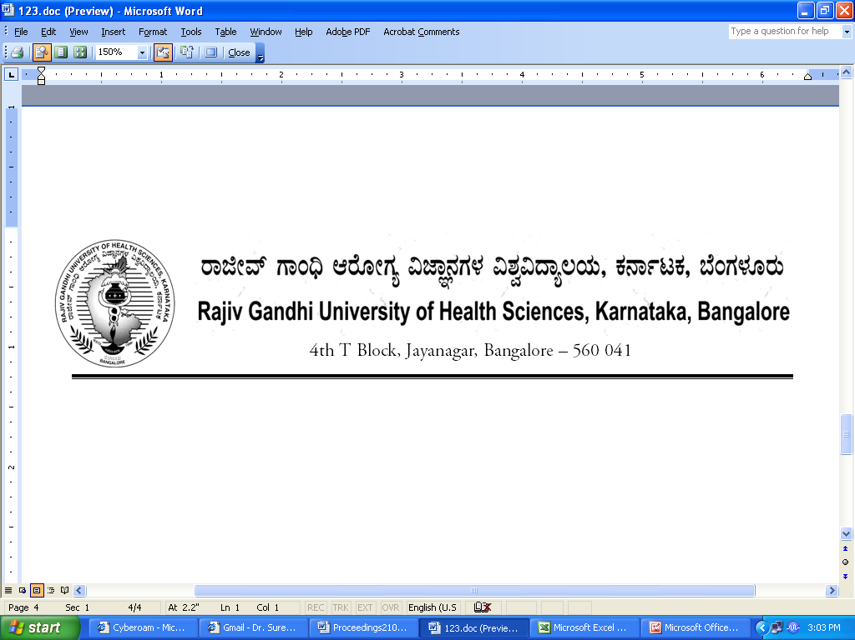
Reg(E)Exam/PG/April- 2018 Date: 08/01/2018

ADVANCE NOTIFICATION

Sub: | Conduct of Post Graduate Degree / Diploma Theory Examination during April- 2018.
********

The Post Graduate Degree / Diploma Theory Examination for the below mentioned courses will tentatively commence from 09th April - 2018. The detailed Time Table will be notified in due courses.

 | COURSES | DATE
I | MD/MS Ayurveda, MD Homoeopathy, MD Unani, MD Naturopathy, M.P.T, M.H.A, M.Sc. Nursing, M.Sc. MLT, MPH, M.Sc. Psychosocial Rehabilitation, M.Sc Clinical Psychology, M.Sc Clinical Research, M.Sc. Perfusion Technology, M.Sc. Echocardiography & M.Sc. Radiation Physics. | 09th April - 2018

The Principals of the concerned Colleges are requested to notify this on the Notice Board of their colleges for information of the students concerned.

Sd/-

Registrar (Evaluation)
To:
All the Principals of the concerned colleges for information and needful action.

Copy to:

- PA to Vice-Chancellor/Registrar/Finance Officer, RGUHS, Bangalore.
- Deputy Registrar (Admn) section for information and needful action.
- All the officers of the RGUHS, Bangalore.
- Asst. Registrar, Regional Center, Belgaum / Gulbarga.
- Guard File.

